**Assignment 03**

***Problem 1 :***

Method A :

Big O Complexity of Method A is N3

Method B:

Big O Complexity of Method B is N

Method C:

Big O Complexity of Method B is N * Log2 N

***Problem 2 :***

Big O Complexity of BubbleSort is N2

**Result :**

For Input Array of length 5

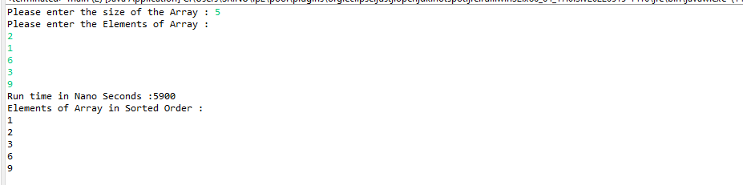

For Input Array of length 7

